Female #12678 – Spruce breeding physiology profile 2016

Physiology profile during and after breeding

Physiology graphs of female Mt. Graham red squirrel (Spruce) prior to breeding occurrence and through gestation.

Estradiol: N=489 M=1067.7, SD=568.1, SE=25.88

Progesterone: N=489 M=242.4,SD=93.68, SE=4.3

Cortisol: N=489, M=473.420, SD=700.30,SE=31.9

Copulation observed on May 13, 2016 at 10:30 am. Estradiol level had peaked the previous day, but ovulation is indicated when estradiol levels drop, followed by an increase in progesterone.

Pregnancy confirmed after the fact by the initial progesterone spike to 488ng/g, then maintenance of progesterone level above baseline, from 5-16-16 to 6-24 16, when it fell to below baseline of 159.5ng/g.

A cortisol spike to 6122.01 ng/g occurred two days after the breeding, and again on 7/21/16. The second spike of 10838.ng/g cooresponded to the HVAC failing in the breeding center, and the temperature exceeding 82F.

Estradiol decreases just prior to ovulation 747.7ng/g, (Eckert and Randall, 1983)

Cortisol peak of

10838.0ng/g- to 488 ng/g

HVAC fails, temp exceeded 82F on 7/21/2016

Progesterone increase

228 5 ng/g- to 488 ng/g

Cortisol level =6122.01ng/g

5-15-2016

Reproductive Physiology

We observed a pattern of increases estradiol indicative of estrous and cyclicity occurring throughout the year

Fecal collection began immediately after acquisition, and the evidence of cyclicty was observed in the first samples collected from these squirrels after they were brought to the Center from the wild.

The apparent cyclicity coupled with behavioral assessment may help increase the chances of achieving successful reproduction of Mt. Graham red squirrels.

**Spruce Estradiol 2016**

**N=333, M=1143.4 Ng/g, SD=576.4 SE=32.9**

Behavior and Physiology

By conducting behavioral observation during reproductive assessments we were able to track the changes in aggressive responses between the males and the females.

Subsequently upon examination of the fecal hormone analysis we determined that a reduction in aggressive responses from the males was closely associated with peaks in estradiol.

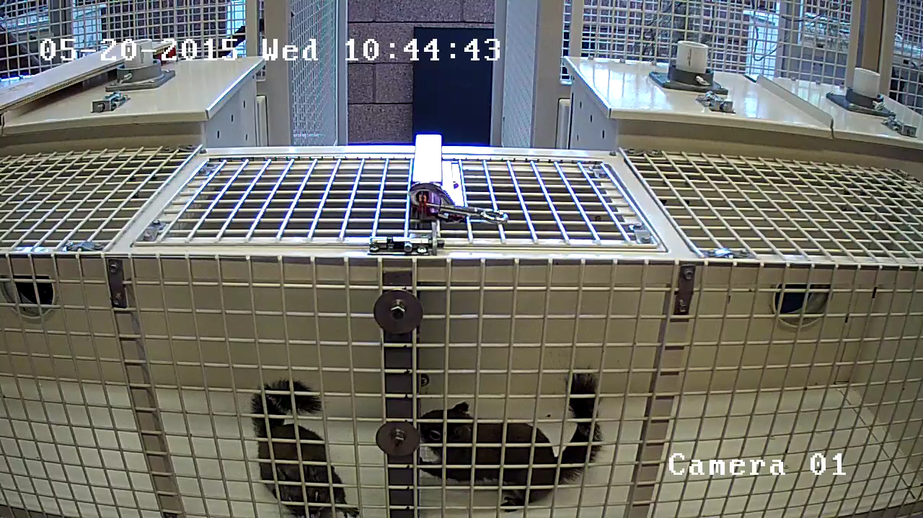

June 2017

|  |  |  |  |  |  |  |
| --- | --- | --- | --- | --- | --- | --- |
| *Sunday* | *Monday* | *Tuesday* | *Wednesday* | *Thursday* | *Friday* | *Saturday* |
|  |  |  | *31* | *1* | *2* | *3* |
|  |  |  | *Day -3* | *Day -2* | *Day -3* | ***Peak - S*** |
| *4* | *5* | *6* | *7* | *8* ***Peak - M*** | *9* | *10* |
| *Day +1* | *Day -3*  *Day +2* | *Day -2*  *Day +3* | *Day -1*  Safe Introduction Window |  | *Day +1* | *Day +2* |
| *Day +3* | *12* | *13* | *14* | *15* | *16* | *17* |
|  |  |  |  |  |  |  |
| *18* | *19* | *20* | *21* | *22* ***Peak -S*** | *23eak M* | *24* |
|  |  |  |  |  | *Peak - M* |  |
| *25* | *26* | *27* | *28* | *29* | *30* |  |
|  |  |  |  |  |  |  |
|  |  |  |  |  |  |  |
|  |  |  |  |  |  |  |

We plotted out the peak estradiol dates from the previous year for each female and scheduled reproductive assessments based upon those dates. We found that aggressive interactions were reduced when we conducted the reproductive assessment within the seven-day window (Day -3 to Day +3) around the peak estradiol point. We also found that introductions could be safely conducted within the three-day window (day -1 to day 1). We conducted eight introductions during the 2017 season with two overnight introductions occurring (day -1 to Day +1 where the animals remained accessed to each other throughout the evening.

Summary

We have achieved one breeding of Mt. Graham red squirrel since the pilot breeding program began with the acquisition new animals from the wild. We currently hold three males and two female Mt. Graham red squirrels. We can keep six animals in our new Multi-species conservation center, and the potential to house four additional animals in the current MGRS breeding Center if we can acquire funding to construct four new enclosures, and support for additional staff. Additional potential breeding animals prepared for release to the wild is critical for future supplementation of the wild population. Short term housing of this species may be problematic due to their territorial nature, and their sensitivity to sounds and temperature. Our new multi-species building has the dual HVAC backup, and the existing Center has a larger capacity HVAC that is new. However, these are the only facilities on grounds with that capability.

In a short period, we have gained a great deal of knowledge towards establishing a consistent breeding management program for the Mt. Graham red squirrel. We were impacted during this year’s breeding season by noise created during the construction of the new facility. Scheduling delays caused the heavy construction to occur at the peak of the breeding season for these squirrels. We documented stress-related behavioral and physiological manifestations of hyper-vigilance and diarrhea. We will know more about the physiological affects once we receive the results of 2017 fecal steroid analysis.

The main components missing for consistent success are as follows

* A rapid turnaround for physiological assessment.
  + If we could get the fecal samples analyzed from the first 20 days of the year, we could use this information to plot out the cycle for the breeding season. This requires funds to recruit dedicated technician to process and analyze the samples. $12,000.
* A technician dedicated to conducting the reproductive assessments during the breeding season.
  + Conducting the reproductive assessment requires training in recognizing the behaviors indicative of readiness and knowledge of how to score the behaviors. 12, 000
* Construction of four additional squirrel enclosures and transfer tunnels. $24,000
  + We will need to house these squirrels within appropriate enclosures which will help to maintain their ability to return to and survive in the wild.